Absolute Beginner’s Guide to Web Development Lab Contents

Absolute Beginner’s Guide to Web Development Workshop 2

Workshop Overview 2

Quick Points 2

Github Login 3

HTML Updates 4

<head> section updates 4

<body> section updates 4

CSS Updates 7

jQuery Updates 9

Lab Overview 10

Equipment and Implementation Requirements 10

Add Content to <body> 11

Add Content to Your CSS File 14

Add Content to Your jQuery File 17

Additional Resources 18

# Absolute Beginner’s Guide to Web Development Workshop

# Workshop Overview

For this workshop, we are going to use Github Pages to create, edit, and manage HTML, CSS and JavaScript (jQuery) content.

### Quick Points

1. Google Chrome is the best browser to use for this workshop.
2. At times you will need to clear the browser cache for changes to appear (CTRL+SHIFT+DEL in Chrome).

IMPORTANT: In the dialog box, be sure to uncheck the box next to **Clear Cookies and Other Site Data**.

1. Once you clear the cache, you may need to log into Github again. The login info is available in the header of every page throughout this document (after this page).

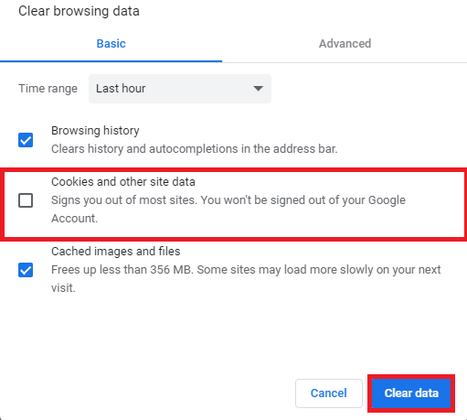

1. Have fun and be patient – lots of new material and moving parts! 😊

### Github Login

1. Go to github.com
2. Sign in with the following username and password

**username**: mooweb

**password**: Pass@word123!

1. Once you are signed in, type the following website address in the address bar and click **enter: http://tiny.cc/jan30-files**
2. Click on the folder with your name on it
3. Click on the file titled **index.html**
4. Click the small pencil icon above the file content to begin editing the file: 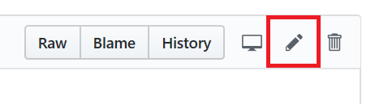

### HTML Updates

Update following content in your index.html document:

### <head> section updates

1. Change the content attribute to your name, change the title tag to a page tab title you prefer

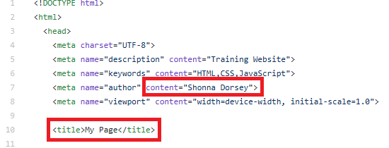

### <body> section updates

1. Change the **<div>** color names on lines 21 and 22 to colors you prefer.

**Current HTML Content:**

Line 21: <div id=’color1’></div>

Line 22: <div id=’color2’></div>

**Example Update:**

Line 21: <div id = ‘orange’></div>

Line 22: <div id = ‘yellow’></div>

1. Update the **<p>** content on lines 28 and 29 to your own text.
2. Update the **<a>** tag on line 34 to refer to a web page you prefer.
3. Update the **<img>** tag on line 37 to refer to a link and image you prefer. See info below on how to add an open source image.

#### How to Add an Open Source Image from pexels.com in **Google Chrome**

1. Go to pexels.com.
2. Search for a photo you like.
3. Right click on the photo and click on **Copy Image Address**. **This step is specific to Google Chrome.**
4. Return to index.html and replace the # sign on line 37 with the link you copied.

**Original:** <img src=’#’>

**Updated:**

<img src=’<https://images.pexels.com/photos/33109/fall-autumn-red-season.jpg?auto=compress&cs=tinysrgb&h=750&w=1260>’>

1. In the address you pasted, **remove** everything in the link after the image extension. In this case, the image extension is .jpg – delete everything after .jpg.

**Original pasted link:** https://images.pexels.com/photos/33109/fall-autumn-red-season.jpg?auto=compress&cs=tinysrgb&h=750&w=1260

**Updated link:** https://images.pexels.com/photos/33109/fall-autumn-red-season.jpg

1. **Scroll to the bottom of the page and click the green Commit Changes button to save your changes.**

To view the changes in the browser, type **tiny.cc/jan-30/firstname/** and click enter.

**You may need to refresh your browser cache to view changes (CTRL+SHIFT+DEL)**

### CSS Updates

1. Return to Github.com.
2. Go to the following address: **tiny.cc/jan30-files**.
3. Click on the folder with your name on it and click on the css folder.
4. Open style.css and click the edit button to make the following updates:

1. Resize the divs and images by typing the following info:

div, img {

height: 12em;

width: 12em;

display: inline-block;

margin: 1em;

}

1. Animate your divs

div {animation: recolor 5s infinite;}

@keyframes recolor {to {background: green;}}

1. Change the background color of your divs:

#red {background: #ff0000;}

#green {background: #00cc44;}

Find hex codes if you’d like custom colors at the following link: <http://tiny.cc/color-picker>

To view the changes in the browser, type **tiny.cc/jan-30/firstname/** and click enter.

**You may need to refresh your browser cache to view changes (CTRL+SHIFT+DEL)**

### jQuery Updates

1. Return to Github.com.
2. Go to the following address: tiny.cc/jan30-files.
3. Click your named folder
4. Click the js folder.
5. Open script.js and click the edit to make the following changes:

**Line 1: $(document).ready(function(){**

Line 2: $('#rounded').click(function(){

Line 3: $('div').css({'border-radius':'10em'});

Line 4: });

Line 5: $('p').click(function(){

Line 6: $('#custom').css({'background':'yellow'});

Line 7: });

Line 8: });

To view the changes in the browser,

type **tiny.cc/jan-30/firstname/** and click Enter

Lab Overview

During this lab, you will use Github Pages to create a live, working web page you can access from any device. By working through the steps in this lab, you will create a web page from scratch using the tools and technologies discussed in the introduction to web development workshop.

The page we will be building for this section of the workshop will feature an animated CSS button that when clicked, changes the entire look and feel of the page (we will use jQuery to achieve this outcome).

## Equipment and Implementation Requirements

* Testing devices (laptop, smartphone)
* Recommended browser - Google Chrome

**Let’s get started!**

### Add Content to <body>

1. After the opening <body> tag, add two divs with IDs. Set the IDs to colors of your choice.

**Example:**

<div id=’red’></div>

<div id=’yellow’></div>

1. Add two photos to the page using pexels.com. Type the following placeholder info on the two lines below the divs you’ve added to the HTML document:

<img src=’#’ alt=’IMAGE DESCRIPTION’>

<img src=’#’ alt=’IMAGE DESCRIPTION’>

#### How to Add an Open Source Image from pexels.com (in Chrome)

1. Go to pexels.com.
2. Search for a photo you like.
3. Right click on the photo and click on **Copy Image Address**.
4. Return to index.html and replace the # sign after the img src reference with the link you copied.

**Original:** <img src=’#’>

**Updated:** <img src=’<https://images.pexels.com/photos/33109/fall-autumn-red-season.jpg?auto=compress&cs=tinysrgb&h=750&w=1260>’>

1. In the address you pasted, **remove** everything in the link after the image extension. In this case, the image extension is .jpg – delete everything after .jpg.

**Original pasted link:** https://images.pexels.com/photos/33109/fall-autumn-red-season.jpg?auto=compress&cs=tinysrgb&h=750&w=1260

**Updated link:** https://images.pexels.com/photos/33109/fall-autumn-red-season.jpg

1. Add a button to your page:

Example: <button>Click Here!</button>

1. Add two hyperlinks to the page:

Example: <a href=’#’ >INSERT LINK TEXT</a>

Replace the # with a website address. **Remember to include http:// or http:// before the website address link.**

1. Add two paragraphs of text to the page using <p> tags. Make sure one of your paragraphs has an id.

**Example:**

**<p id=’green-paragraph’>INSERT TEXT</p>**

Commit changes and review your work at

**tiny.cc/jan-30/firstname/lab/index.html**

### Add Content to Your CSS File

1. Open the style.css file in the css folder
2. Update all pictures to be 10em x 10em using the height and width properties.

**Example:**

**img {**

**height: 10em;**

**width: 10em;**

**}**

1. Remove all formatting from hyperlinks until you hover over them.

**Example:**

**a {text-decoration: none;}**

1. Add an underline and background color when the user hovers over the link:

**Example:**

**a:hover {**

**text-decoration: underline;**

**background: yellow;**

**}**

1. Change the height and width of all divs, make sure they display next to each other and animate the divs with a background color:

**Example:**

**div {**

**height: 10em;**

**width: 10em;**

**background: INSERT COLOR;**

**display: inline-block;**

**animation: recolor 5s infinite;**

**}**

1. Update your custom IDs to custom background colors.

**Example in index.html: <div id=’red’></div>**

**Example in CSS:**

**#red {**

**background: red;**

**}**

1. Set your div animations:

**Example:**

**@keyframes recolor {**

**to {background: INSERT COLOR;}**

**}**

1. Add a media query to change the background color on the page when it is narrower than 600px wide:

**Example:**

**@media only screen and (max-width: 600px) {**

**body {**

**background-color: green;**

**}**

**}**

**Commit changes and review your work at**

**tiny.cc/jan-30/lab/firstname/index.html**

### Add Content to Your jQuery File

1. Make it so that individual divs disappear when the user clicks on them.

**Example:**

**Line 1: $(document).ready(function(){**

**Line 2: $(‘div’).click(function(){**

**Line 3: $(this).hide();**

**Line 4: });**

1. Change images to circles when the user clicks them (add this right below the first function):

**Example**

**Line 5: $(‘img’).click(function(){**

**Line 6: $(‘img’).css({‘border-radius’: ‘100px’});**

**Line 7: });**

**Line 8: });**

**Commit changes and review your work at**

**tiny.cc/jan-30/lab/firstname/index.html**

# Additional Resources

**Free online coding courses:**

1. Codecademy – free online web development tutorials: <https://www.codecademy.com/>
2. FreeCodeCamp – learn to code for free. Opportunities to help nonprofits: <https://learn.freecodecamp.org/> -

**Code Snippets**

1. w3schools- Great resource for getting stared with front end development: <https://www.w3schools.com/>
2. css-tricks - Tips and tricks for CSS. Great help forum: <https://css-tricks.com/>
3. Codepen - Creative uses of jQuery, JavaScript, CSS: <https://codepen.io/>

**Code Editors**

Atom - Developed by Github: <https://atom.io/> -

Brackets- lightweight, powerful: <http://brackets.io/>